Version 1.0

PROJECT 2

RELATIONAL DATABASE DESIGN AND SQL

Project Report

Submitted to teacher Mark Bacchus

As a requirement of the COMP 1630 – CRN 59004

British Columbia Institute of Technology

July 2016

by: lILIEK SIDHARTA

A00821393

# Table of content

# Introduction

In this final project of COMP 1630 CRN 59004 we implement SQL (Structured Query Language) DDL (Data Definition Language) and DML (Data Manipulation Language) that we have learned in the class to manage structured data in a relational database.

The purpose of this implementation is to use DDL and DML to interact with a relational database. DDL (CREATE, ALTER, DROP) will be used for creating database, creating tables, defining tables’ primary keys and foreign keys, and setting the column constraints. DML (INSERT, UPDATE, DELETE) will be used for querying several tables to select records that have matching value; creating virtual table VIEW to allow users to access data without granting permission to access underlying tables; creating stored procedures and triggers which are very useful and can have parameters and passing output values.

The project gives 35 tasks to work on and provides table design and requirements. To accomplish these tasks, we implement SQL in Microsoft SQL Server 2016 Professional Edition on SQL Server Management Studio (SSMS) 17 environment. For reporting, SQL code is formatted using Poor Man’s T-SQL Formatter Extension on Visual Studio Code.

# DATABASE AND TABLES

## Create database Cus_Orders

Create a database called **Cus_Orders**.

### sql statements

USE master

GO

*-- if there is any Cus_Orders database, drop it*

IF EXISTS (

        SELECT *

        FROM sysdatabases

        WHERE name = 'Cus_Orders'

        )

BEGIN

    RAISERROR (

            'Dropping existing Cus_Orders...',

            0,

            1

            )

    DROP DATABASE Cus_Orders

END

GO

RAISERROR (

        'Creating Cus_Orders database...',

        0,

        1

        )

*-- create a new Cus_Orders database*

CREATE DATABASE Cus_Orders

GO

### result

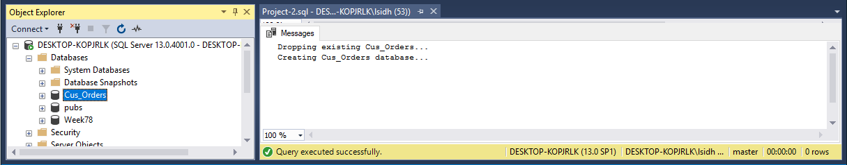

## Create a user defined data types

Create a user defined data types for all similar Primary Key attribute columns (e.g. order_id, product_id,title_id**),** to ensure the same data type, length and null ability. See pages 12/13 for specifications.

There are three data types used by paimary keys of eight tables in database Cus_Orders.

|  |  |  |
| --- | --- | --- |
| User-define Data Type | Data Type | For attributes |
| numid | integer | order_id, product_id, employee_id, shipper_id |
| char3id | char(3) | title_id |
| char5id | char(5) | customer_id |

### SQL Statements

EXECUTE sp_addtype numid,

    'int',

    'NOT NULL';

EXECUTE sp_addtype char3id,

    'char(3)',

    'NOT NULL';

EXECUTE sp_addtype char5id,

    'char(5)',

    'NOT NULL';

GO

### result

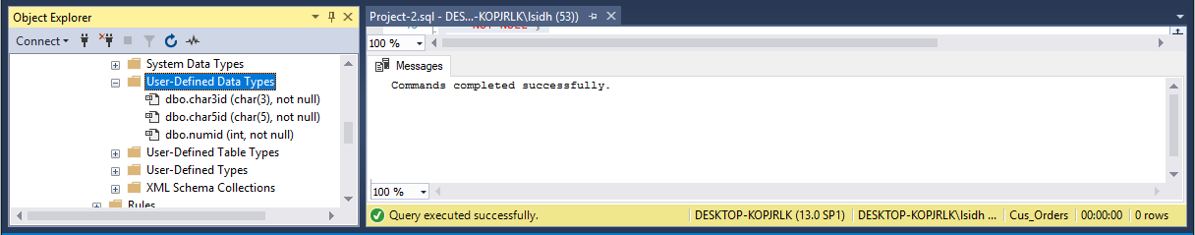

## Create seven tables in database cus_orders

Create the following tables (see column information in Apendix A): customers, orders, order_details, products, shippers, suppliers, titles.

### SQL Statements

CREATE TABLE customers (

    customer_id char5id,

    name VARCHAR(50),

    contact_name VARCHAR(30),

    title_id char3id,

    address VARCHAR(50),

    city VARCHAR(20),

    region VARCHAR(15),

    country_code VARCHAR(10),

    country VARCHAR(15),

    phone VARCHAR(20),

    fax VARCHAR(20)

    );

CREATE TABLE orders (

    order_id numid,

    customer_id char5id,

    employee_id numid,

    shipping_name VARCHAR(50),

    shipping_address VARCHAR(50),

    shipping_city VARCHAR(20),

    shipping_region VARCHAR(15),

    shipping_country_code VARCHAR(10),

    shipping_country VARCHAR(15),

    shipper_id INT,

    order_date DATETIME,

    required_date DATETIME,

    shipped_date DATETIME,

    freight_charge MONEY

    );

CREATE TABLE order_details (

    order_id numid,

    product_id numid,

    quantity INT,

    discount FLOAT

    );

CREATE TABLE products (

    product_id numid,

    supplier_id INT,

    name VARCHAR(40),

    alternate_name VARCHAR(40),

    quantity_per_unit VARCHAR(25),

    unit_price MONEY,

    quantity_in_stock INT,

    units_on_order INT,

    reorder_level INT

    );

CREATE TABLE shippers (

    shipper_id INT IDENTITY(1, 1),

    name VARCHAR(20)

    );

CREATE TABLE suppliers (

    supplier_id INT IDENTITY(1, 1),

    name VARCHAR(40),

    address VARCHAR(30),

    city VARCHAR(20),

    province CHAR(2)

    );

CREATE TABLE titles (

    title_id char3id,

    description VARCHAR(35)

    );

GO

Based on the table design requirement, we can construct the following table to help us defining the NOT NULL constraints.

### CONSTRAINT NOT NULL

|  |  |  |  |
| --- | --- | --- | --- |
| TABLE | COLUMN | DATA TYPE | CONSTRAINT TYPE |
| titles | description | varchar(35) | NOT NULL |
| customers | name | varchar(50) | NOT NULL |
| shippers | name | varchar(20) | NOT NULL |
| products | name | varchar(40) | NOT NULL |
| suppliers | name | varchar(40) | NOT NULL |
| order_details | quantity | int | NOT NULL |
| order_details | discount | float | NOT NULL |
| employee | last_name | varchar(30) | NOT NULL |
| employee | first_name | varchar(15) | NOT NULL |
| employee | birth_date | datetime | NOT NULL |

*-- Set tables not null constraints*

ALTER TABLE titles

ALTER COLUMN description VARCHAR(35) NOT NULL;

ALTER TABLE customers

ALTER COLUMN name VARCHAR(50) NOT NULL;

ALTER TABLE shippers

ALTER COLUMN name VARCHAR(20) NOT NULL;

ALTER TABLE products

ALTER COLUMN name VARCHAR(40) NOT NULL;

ALTER TABLE suppliers

ALTER COLUMN name VARCHAR(40) NOT NULL;

ALTER TABLE order_details

ALTER COLUMN quantity INT NOT NULL;

ALTER TABLE order_details

ALTER COLUMN discount FLOAT NOT NULL;

GO

### result

Seven new tables created are shown in the Object Explorer section of SSMS window.

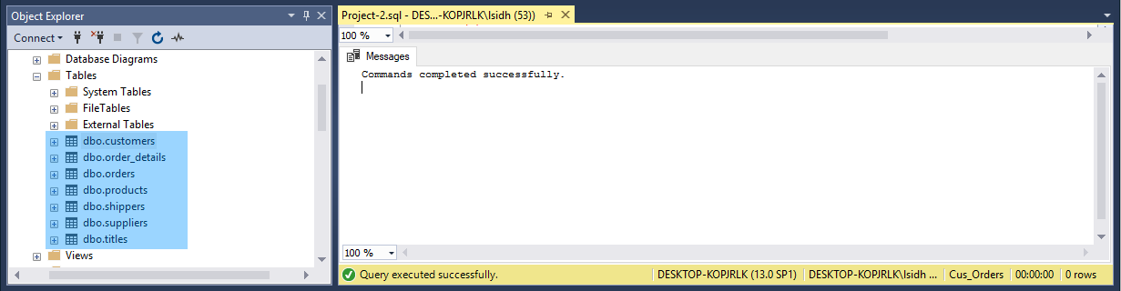

The columns created together with the table are shown under the Column section. The picture below shows table customers, its columns, data type and column properties.

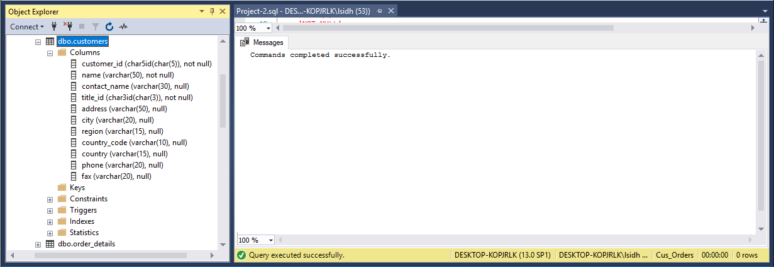

## Set primary keys and foreign keys

Set the **primary** **keys** and **foreign** **keys** for the tables.

Based on the table design provided in the project requirements, we can construct these table before implement the SQL code to define primary keys and foreign keys.

### CONSTRAINT PRIMARY KEY

|  |  |  |
| --- | --- | --- |
| TABLE | COLUMN | CONSTRAINT TYPE |
| title | title_id | PRIMARY KEY |
| customer | customer_id | PRIMARY KEY |
| shippers | shipper_id | PRIMARY KEY |
| suppliers | supplier_id | PRIMARY KEY |
| products | product_id | PRIMARY KEY |
| orders | order_id | PRIMARY KEY |
| employee | employee_id | PRIMARY KEY |

### CONSTRAINT FOREIGN KEY

|  |  |  |  |
| --- | --- | --- | --- |
| TABLE | COLUMN | REFERENCE TO | CONSTRAINT TYPE |
| customers | title_id | Titles | FOREIGN KEY |
| products | supplier_id | suppliers | FOREIGN KEY |
| orders | customer_id | customers | FOREIGN KEY |
| orders | shipper_id | shippers | FOREIGN KEY |
| order_details | order_id | orders | FOREIGN KEY |
| order_details | product_id | products | FOREIGN KEY |

### Sql statements

In this project, primary keys and foreign keys are defined using ALTER TABLE.

ALTER TABLE titles ADD PRIMARY KEY (title_id);

ALTER TABLE customers ADD PRIMARY KEY (customer_id);

ALTER TABLE customers ADD CONSTRAINT FK_customers FOREIGN KEY (title_id) REFERENCES titles (title_id);

ALTER TABLE shippers ADD PRIMARY KEY (shipper_id);

ALTER TABLE suppliers ADD PRIMARY KEY (supplier_id);

ALTER TABLE products ADD PRIMARY KEY (product_id);

ALTER TABLE products ADD CONSTRAINT FK_products FOREIGN KEY (supplier_id) REFERENCES suppliers (supplier_id);

ALTER TABLE orders ADD PRIMARY KEY (order_id);

ALTER TABLE orders ADD CONSTRAINT FK_orders1 FOREIGN KEY (customer_id) REFERENCES customers (customer_id);

ALTER TABLE orders ADD CONSTRAINT FK_orders2 FOREIGN KEY (shipper_id) REFERENCES shippers (shipper_id);

ALTER TABLE order_details ADD CONSTRAINT PK_order_details PRIMARY KEY (

    order_id,

    product_id

    );

ALTER TABLE order_details ADD CONSTRAINT FK_order_details1 FOREIGN KEY (order_id) REFERENCES orders (order_id);

ALTER TABLE order_details ADD CONSTRAINT FK_order_details2 FOREIGN KEY (product_id) REFERENCES products (product_id);

GO

### RESULT

MMSM’s Object Explorer lists primary keys and foreign keys in a table’s key section. The following picture shows table **customers** and **order_details** primary keys and foreign keys in two blue rectangles.

### 

## Set the constraints

Set the **constraints** as follows:

* **customers** **table** - country should default to Canada
* **orders** **table** - required_date should default to today’s date plus ten days
* **order details table** - quantity must be greater than or equal to 1
* **products table** - reorder_level must be greater than or equal to 1, quantity_in_stock value must not be greater than 150
* **suppliers table** - province should default to BC

### CONSTRAINT DEFAULT

|  |  |  |  |
| --- | --- | --- | --- |
| TABLE | COLUMN | Default value | CONSTRAINT TYPE |
| customers | country | Canada | DEFAULT |
| suppliers | province | BC | DEFAULT |
| orders | required_date | getdate() + 10 | DEFAULT |

### CONSTRAINT CHECK

|  |  |  |  |
| --- | --- | --- | --- |
| TABLE | COLUMN | check value | CONSTRAINT TYPE |
| products | quantity_in_stock | <= 150 | CHECK |
| products | reorder_level | >= 1 | CHECK |
| order_details | quantity | >= 1 | CHECK |

### sql statements

*-- Set table customers' country default value*

ALTER TABLE customers ADD CONSTRAINT DF_country DEFAULT 'Canada'

FOR country;

*-- Set table suppliers' province default value*

ALTER TABLE suppliers ADD CONSTRAINT DF_province DEFAULT 'BC'

FOR province;

*-- Set table products constraint values*

ALTER TABLE products ADD CONSTRAINT CH_stockqty CHECK (quantity_in_stock <= 150);

ALTER TABLE products ADD CONSTRAINT CH_reorderlv CHECK (reorder_level >= 1);

*-- Set table orders default values*

ALTER TABLE orders ADD CONSTRAINT DF_date DEFAULT(**getdate**() + 10)

FOR required_date;

*-- Set table order_details constraint values*

ALTER TABLE order_details ADD CONSTRAINT CH_qty CHECK (quantity >= 1);

GO

### Result

The **check** and **default** column constraints for a table are listed under constraints section of each table, as it is shown in the following table for **customers** and **order_details** tables.

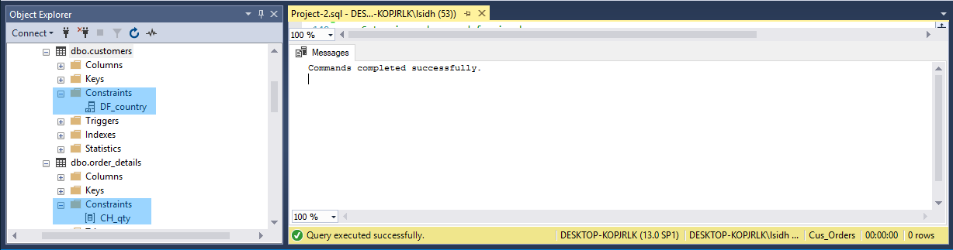

## Load data into created tables except table employees

Load the data into your created tables using the following files:

* customers.txt into the customers table (91 rows)
* orders.txt into the orders table (1078 rows)
* order_details.txt into the order_details table (2820 rows)
* products.txt into the products table (77 rows)
* shippers.txt into the shippers table (3 rows)
* suppliers.txt into the suppliers table (15 rows)
* titles.txt into the titles table (12 rows)

### SQL Statements

BULK INSERT titles

FROM 'C:\TextFiles\titles.txt' WITH (

        CODEPAGE = 1252,

        DATAFILETYPE = 'char',

        FIELDTERMINATOR = '\t',

        KEEPNULLS,

        ROWTERMINATOR = '\n'

        );

BULK INSERT suppliers

FROM 'C:\TextFiles\suppliers.txt' WITH (

        CODEPAGE = 1252,

        DATAFILETYPE = 'char',

        FIELDTERMINATOR = '\t',

        KEEPNULLS,

        ROWTERMINATOR = '\n'

        );

BULK INSERT shippers

FROM 'C:\TextFiles\shippers.txt' WITH (

        CODEPAGE = 1252,

        DATAFILETYPE = 'char',

        FIELDTERMINATOR = '\t',

        KEEPNULLS,

        ROWTERMINATOR = '\n'

        );

BULK INSERT customers

FROM 'C:\TextFiles\customers.txt' WITH (

        CODEPAGE = 1252,

        DATAFILETYPE = 'char',

        FIELDTERMINATOR = '\t',

        KEEPNULLS,

        ROWTERMINATOR = '\n'

        );

BULK INSERT products

FROM 'C:\TextFiles\products.txt' WITH (

        CODEPAGE = 1252,

        DATAFILETYPE = 'char',

        FIELDTERMINATOR = '\t',

        KEEPNULLS,

        ROWTERMINATOR = '\n'

        );

BULK INSERT order_details

FROM 'C:\TextFiles\order_details.txt' WITH (

        CODEPAGE = 1252,

        DATAFILETYPE = 'char',

        FIELDTERMINATOR = '\t',

        KEEPNULLS,

        ROWTERMINATOR = '\n'

        );

BULK INSERT orders

FROM 'C:\TextFiles\orders.txt' WITH (

        CODEPAGE = 1252,

        DATAFILETYPE = 'char',

        FIELDTERMINATOR = '\t',

        KEEPNULLS,

        ROWTERMINATOR = '\n'

        );

GO

### Result

The number of records added into the tables are displayed in the Messages section.

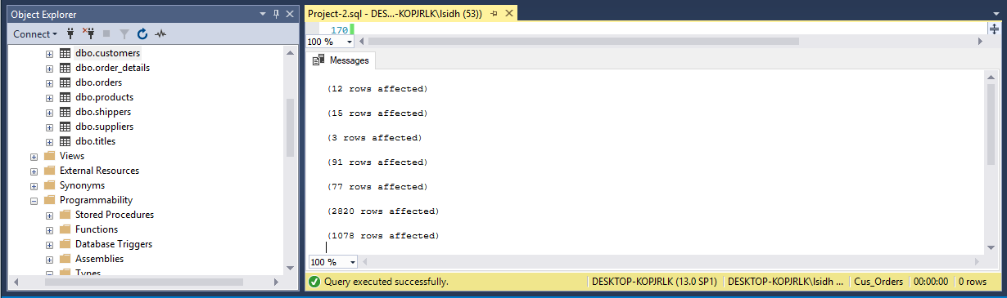

# sql statements

## List of table customers

List the customer id, name, city, and country from the customer table. Order the result set by the **customer id**. The query should produce the result set listed below.

customer_id name city country

--------------- ---------------------------------- ------------- ---------------

ALFKI Alfreds Futterkiste Berlin Germany

ANATR Ana Trujillo Emparedados y helados México D.F. Mexico

ANTON Antonio Moreno Taquería México D.F. Mexico

...

(91 row(s) affected)

### Sql statements

SELECT customer_id,

    name,

    city,

    country

FROM customers

ORDER BY customer_id;

GO

### Result

### 

## Add New column active to table customers.

Add a new column called **active** to the customers table using the ALTER statement. The only valid values are 1 or 0. The default should be **1**.

### Sql statements

ALTER TABLE customers ADD active BIT DEFAULT 1;

GO

### result

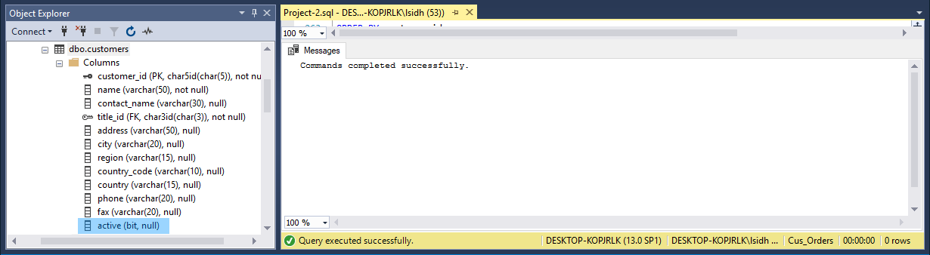

## List all the orders between January and February 2004

List all the orders where the order date is sometime in January or February 2004. Display the order id, order date, and a new shipped date calculated by adding 7 days to the shipped date from the orders table, the product name from the product table, the customer name from the customer table, and the cost of the order. Format the date order date and the shipped date as **MON DD YYYY**. Use the formula (quantity * unit_price) to calculate the cost of the order. The query should produce the result set listed below.

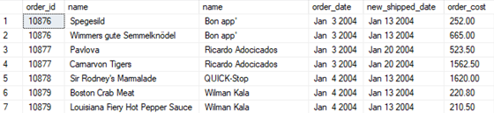

…

(306 rows should be returned)

### sql statements

SELECT o.order_id,

    p.name,

    c.name,

    'order_date' = **CONVERT**(VARCHAR(12), o.order_date, 107),

    'new shipped date' = **CONVERT**(VARCHAR(12), **DATEADD**(**DAY**, 7, o.shipped_date), 107),

    'order_cost' = (od.quantity - od.discount) * p.unit_price

FROM orders o

INNER JOIN order_details od

    ON order_details.order_id = orders.order_id

INNER JOIN products p

    ON order_details.product_id = products.product_id

INNER JOIN customers c

    ON orders.customer_id = customers.customer_id

WHERE orders.order_date BETWEEN 'Jan 1, 2004'

        AND 'Feb 28, 2004';

GO

### result

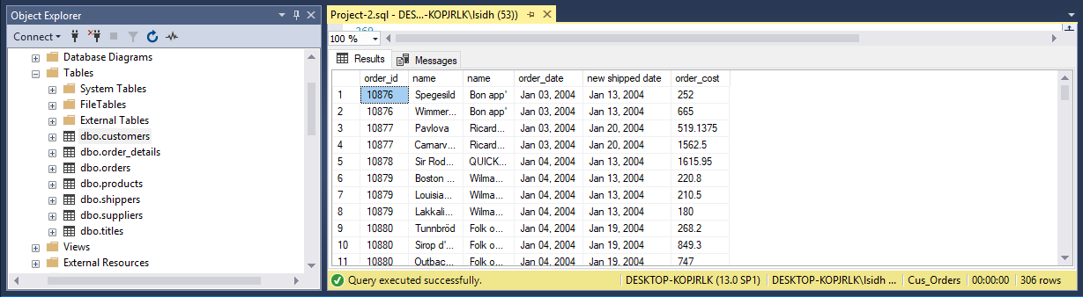

## List all the orders that have not been shipped

List all the orders that have **not** been shipped. Display the customer id, name and phone number from the customers table, and the order id and order date from the orders table. Order the result set by the order date. The query should produce the result set listed below.

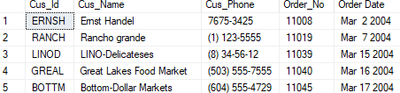

…

(21 row(s) affected)

### sql statements

SELECT c.customer_id,

    c.name,

    c.phone,

    o.order_id,

    'Order Date' = **CONVERT**(VARCHAR(12), o.order_date, 109)

FROM customers c

INNER JOIN orders o

    ON c.customer_id = o.customer_id

WHERE o.shipped_date IS NULL

ORDER BY o.order_date;

GO

### result

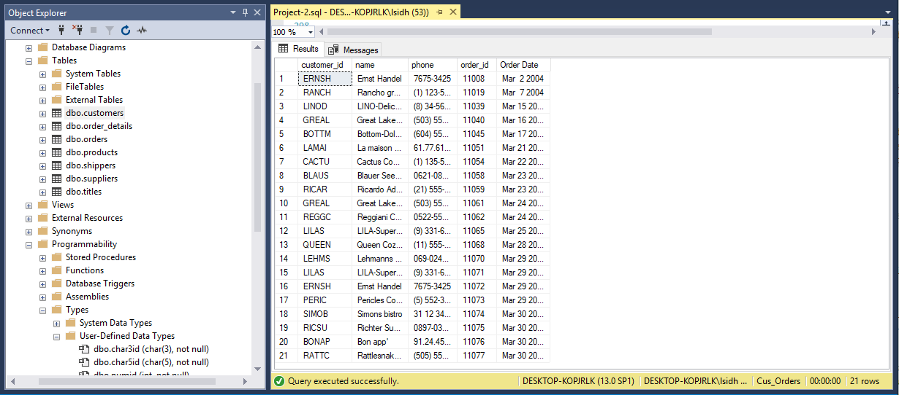

## List all the customers where the region is null

List all the customers where the region is **NULL**. Display the customer id, name, and city from the customers table, and the title description from the titles table. The query should produce the result set listed below.

customer_id name city description

-------------- ----------------------------------- --------------- ----------------------

ALFKI Alfreds Futterkiste Berlin Sales Representative

ANATR Ana Trujillo Emparedados y helados México D.F. Owner

ANTON Antonio Moreno Taquería México D.F. Owner

…

(60 row(s) affected)

### sql statements

SELECT customer_id,

    name,

    city,

    t.description

FROM customers c

INNER JOIN titles t

    ON t.title_id = c.title_id

WHERE region IS NULL;

GO

### result

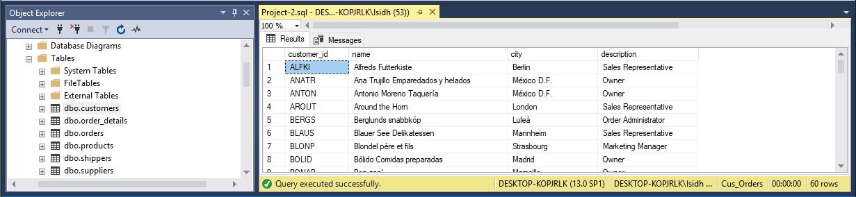

## List the products where the reorder level is higher than stock

List the products where the reorder level is **higher than** the quantity in stock. Display the supplier name from the suppliers table, the product name, reorder level, and quantity in stock from the products table. Order the result set by the supplier name. The query should produce the result set listed below.

supplier_name product_name reorder_level quantity_in_stock

------------------------ --------------------- ---------------- -----------------

Armstrong Company Queso Cabrales 30 22

Cadbury Products Ltd. Ipoh Coffee 25 17

Cadbury Products Ltd. Røgede sild 15 5

...

(18 row(s) affected)

### sql statements

SELECT s.name AS 'supplier_name',

    p.name AS 'product_name',

    p.reorder_level,

    p.quantity_in_stock

FROM products p

INNER JOIN suppliers s

    ON s.supplier_id = p.supplier_id

WHERE reorder_level > quantity_in_stock

ORDER BY s.name;

GO

### result

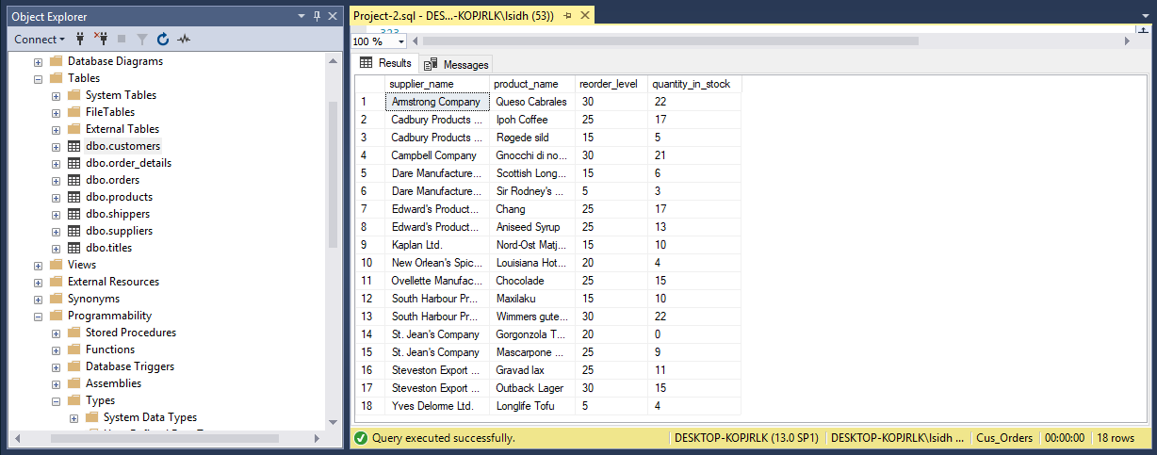

## Calculate the length in years for shipped orders

Calculate the length in years from **January 1, 2008** and when an order was shipped where the shipped date is **not null**. Display the order id, and the shipped date from the orders table, the customer name, and the contact name from the customers table, and the length in years for each order. Display the shipped date in the format MMM DD YYYY. Order the result set by order id and the calculated years. The query should produce the result set listed below.

order_id name contact_name shipped_date elapsed

----------- --------------------------- --------------------------- ------------ -------

10000 Franchi S.p.A. Paolo Accorti May 15 2001 7

10001 Mère Paillarde Jean Fresnière May 23 2001 7

10002 Folk och fä HB Maria Larsson May 17 2001 7

...

(1057 row(s) affected)

### sql statements

SELECT o.order_id,

    c.name,

    c.contact_name,

**CONVERT**(VARCHAR(12), o.shipped_date, 109),

**DATEDIFF**(**year**, o.shipped_date, 'January 1, 2008') AS elapsed

FROM orders o

INNER JOIN customers c

    ON o.customer_id = c.customer_id

WHERE shipped_date IS NOT NULL

ORDER BY o.order_id,

    elapsed;

GO

### result

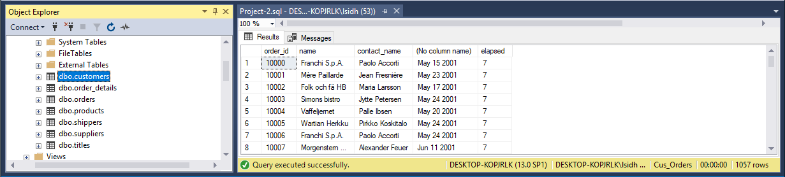

## List of customers’ names with their first letter

List number of customers with names beginning with each letter of the alphabet. Ignore customers whose name begins with the letter F or G. Do not display the letter and count unless **at least six** customer’s names begin with the letter. The query should produce the result set listed below.

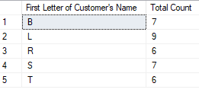

### sql statements

SELECT LEFT(c.name, 1),

**COUNT**(LEFT(c.name, 1)) AS 'Total_Count'

FROM customers c

WHERE (

        LEFT(c.name, 1) <> 'F'

        AND LEFT(c.name, 1) <> 'G'

        )

GROUP BY (LEFT(c.name, 1))

HAVING **COUNT**(LEFT(c.name, 1)) >= 6;

GO

### result

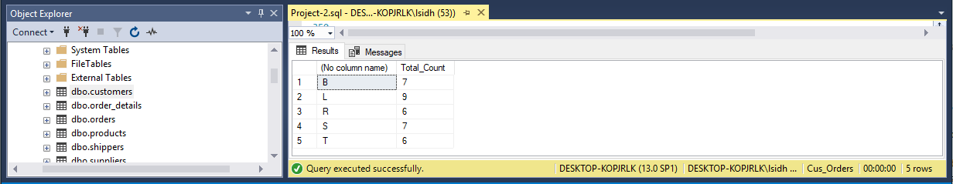

## List the order details where the quantity is greater than 100

List the order details where the quantity is **greater than 100**. Display the order id and quantity from the order_details table, the product id and reorder level from the products table, and the supplier id from the suppliers table. Order the result set by the order id. The query should produce the result set listed below.

order_id quantity product_id reorder_level supplier_id

----------- ----------- -------------- ----------------- -----------

10193 110 43 25 10

10226 110 29 0 12

10398 120 55 20 15

...

(15 row(s) affected)

### sql statements

SELECT od.order_id,

    od.quantity,

    p.product_id,

    p.reorder_level,

    s.supplier_id

FROM order_details od

INNER JOIN products p

    ON od.product_id = p.product_id

INNER JOIN suppliers s

    ON p.supplier_id = s.supplier_id

WHERE quantity > 100;

GO

### result

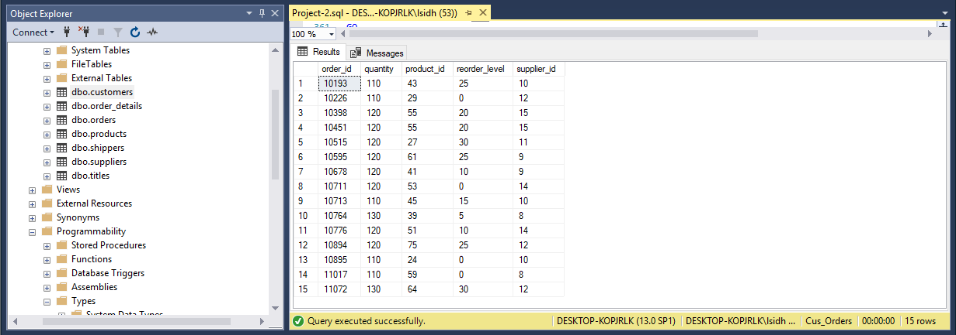

## List the products which contain ‘tofu’ or ‘chef’ in their name

List the products which contain **tofu** or **chef** in their name. Display the product id, product name, quantity per unit and unit price from the products table. Order the result set by product name. The query should produce the result set listed below.

product_id name quantity_per_unit unit_price

-------------- ------------------------------------- ---------------------- --------------

4 Chef Anton's Cajun Seasoning 48 - 6 oz jars 22.0000

5 Chef Anton's Gumbo Mix 36 boxes 21.3500

74 Longlife Tofu 5 kg pkg. 10.0000

14 Tofu 40 - 100 g pkgs. 23.2500

(4 row(s) affected)

### sql statements

SELECT product_id,

    name,

    quantity_per_unit,

    unit_price

FROM products

WHERE name LIKE '%tofu%'

    OR name LIKE '%chef%';

GO

### result

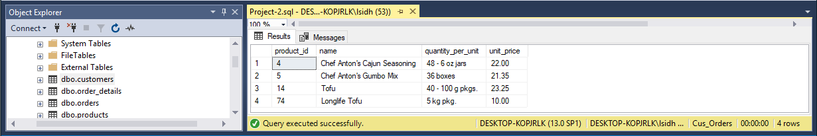

# INSERT, UPDATE, DELETE AND VIEWS STATEMENTS

## Create employee table

### sql statements

CREATE TABLE employee (

    employee_id numid NOT NULL,

    last_name VARCHAR(30) NOT NULL,

    first_name VARCHAR(15) NOT NULL,

    address VARCHAR(30),

    city VARCHAR(20),

    province VARCHAR(2),

    postal_code VARCHAR(7),

    phone VARCHAR(10),

    birth_date DATETIME NOT NULL

    );

GO

### result

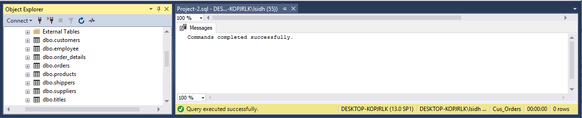

## Set primary key for the employee

The **primary key** for the employee table should be the employee id

### sql statement

ALTER TABLE employee ADD PRIMARY KEY (employee_id);

GO

### result

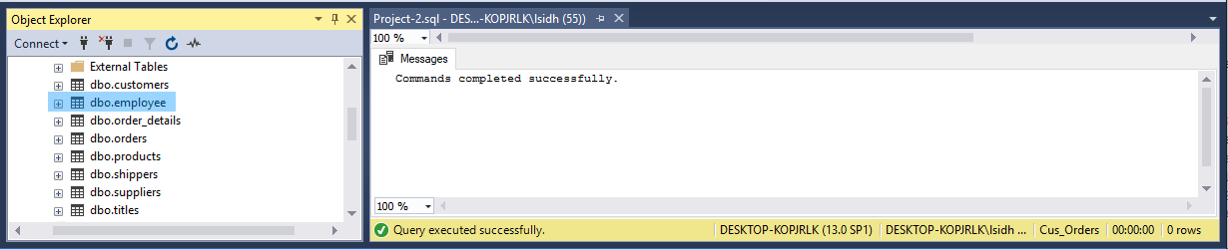

## Load the data into the employee table and create relationship

Load the data into the employee table using the employee.txt file; **9** rows. In addition, **create the relationship** to enforce referential integrity between the employee and orders tables.

### sql statements

BULK INSERT employee

FROM 'C:\TextFiles\employee.txt' WITH (

        CODEPAGE = 1252,

        DATAFILETYPE = 'char',

        FIELDTERMINATOR = '\t',

        KEEPNULLS,

        ROWTERMINATOR = '\n'

        );

GO

*-- Create relationship between employee table and order table*

ALTER TABLE orders ADD CONSTRAINT FK_orders3 FOREIGN KEY (employee_id) REFERENCES employee (employee_id);

GO

### result

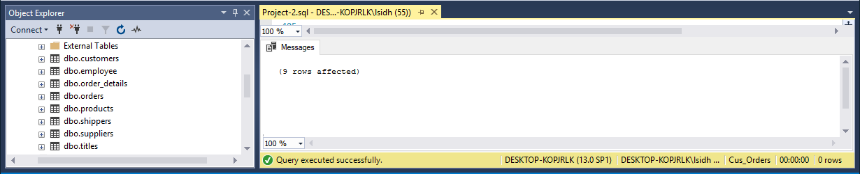

## Add the shipper Quick Express to the shippers table

Using the INSERT statement, add the shipper **Quick Express** to the shippers table.

### sql statement

INSERT INTO shippers

VALUES ('Quick Express');

GO

### result

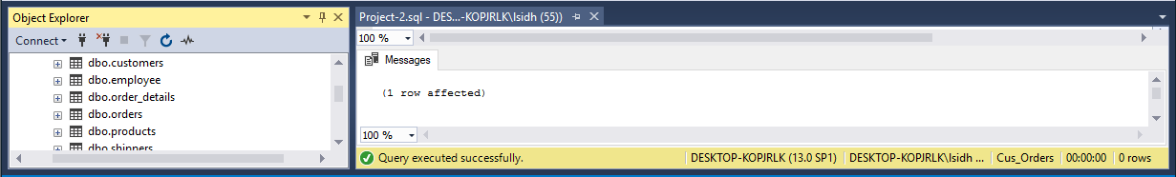

## Increase the unit price in the products table

Using the UPDATE statement, increate the unit price in the products table of all rows with a current unit price between **$5.00** and **$10.00** by **5%**; 12 rows affected.

### sql statement

UPDATE products

SET unit_price = unit_price * 1.05

WHERE unit_price BETWEEN 5.00

        AND 10.00;

GO

### result

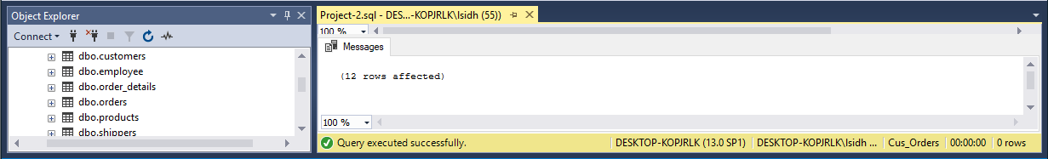

## Change the fax value in the customers table

Using the UPDATE statement, change the fax value to **Unknown** for all rows in the customers table where the current fax value is **NULL**; 22 rows affected.

### sql statement

SET fax = 'Unknown'

WHERE fax IS NULL;

GO

### result

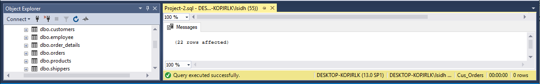

## Create a view called vw_order_cost

Create a view called **vw_order_cost** to list the cost of the orders. Display the order id and order_date from the orders table, the product id from the products table, the customer name from the customers tble, and the order cost. To calculate the cost of the orders, use the formula (order_details.quantity * products.unit_price). Run the view for the order ids between **10000** and **10200**. The view should produce the result set listed below.

order_id order_date product_id name order_cost

--------- ------------------------------ -------------- ------------------------------ --------------

10000 2001-05-10 00:00:00.000 17 Franchi S.p.A. 156.0000

10001 2001-05-13 00:00:00.000 25 Mère Paillarde 420.0000

...

(540 row(s) affected)

### sql statement

CREATE VIEW vs_order_cost

AS

SELECT o.order_id,

    o.order_date,

    p.product_id,

    c.name,

    od.quantity * p.unit_price AS 'order_cost'

FROM orders o

INNER JOIN order_details od

    ON od.order_id = o.order_id

INNER JOIN products p

    ON p.product_id = od.product_id

INNER JOIN customers c

    ON c.customer_id = o.customer_id

WHERE o.order_id BETWEEN 10000

        AND 10200;

GO

*-- To display the list using the vw_order_cost view*

SELECT *

FROM vs_order_cost;

GO

### result

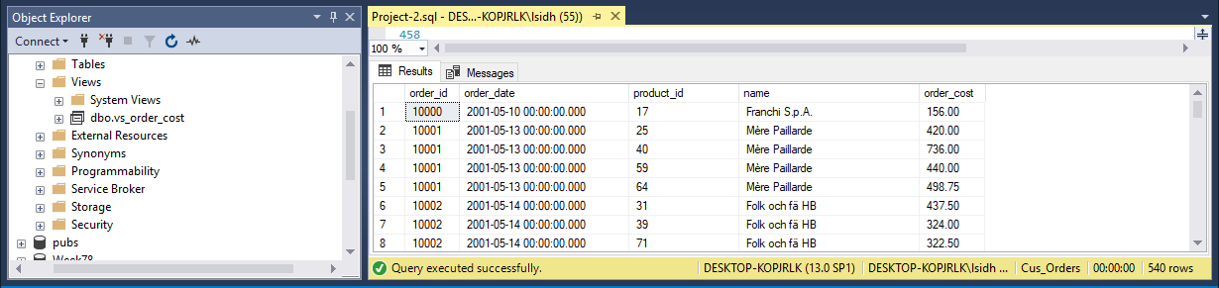

## Create a view called vw_list_employees

Create a view called **vw_list_employees** to list all the employees and all the columns in the employee table. Run the view for employee ids **5**, **7**, and **9**. Display the employee id, last name, first name, and birth date. Format the name as last name followed by a comma and a space followed by the first name. Format the birth date as **YYYY.MM.DD**. The view should produce the result set listed below.

employee_id name birth_date

---------------- -------------------------------- ------------

5 Buchanan, Steven 1955.03.04

7 King, Robert 1960.05.29

9 Dodsworth, Anne 1966.01.27

(3 row(s) affected)

### sql statement

CREATE VIEW vw_list_employee

AS

SELECT *

FROM employee;

GO

*-- To display the list using the above view*

SELECT employee_id,

    (last_name + ', ' + first_name) AS name,

**CONVERT**(VARCHAR(12), birth_date, 102) AS birth_date

FROM vw_list_employee

WHERE employee_id IN (

        5,

        7,

        9

        );

GO

### result

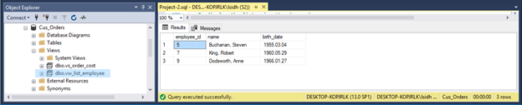

## Create a view called vw_all_orders

Create a view called **vw_all_orders** to list the columns shown below. Display the order id and shipped date from the orders table, and the customer id, name, city, and country from the customers table. Run the view for orders shipped from **August** **1, 2002** and **September 30, 2002**, formatting the shipped date as shown. Order the result set by customer name and country. The view should produce the result set listed below.

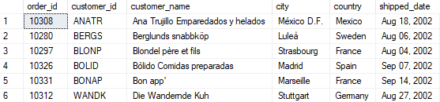

(51 row(s) affected)

### sql statements

CREATE VIEW vw_all_orders

AS

SELECT o.order_id,

    c.customer_id,

    c.name,

    c.city,

    c.country,

    o.shipped_date

FROM orders o

INNER JOIN customers c

    ON o.customer_id = c.customer_id;

GO

*-- To display the list using the above view*

SELECT order_id,

    customer_id,

    name,

    city,

    country,

**CONVERT**(VARCHAR(12), shipped_date, 102) AS shipped_date

FROM vw_all_orders

WHERE shipped_date >= 'Aug 01, 2002'

    AND shipped_date <= 'Sep 30,2002'

ORDER BY name;

GO

### result

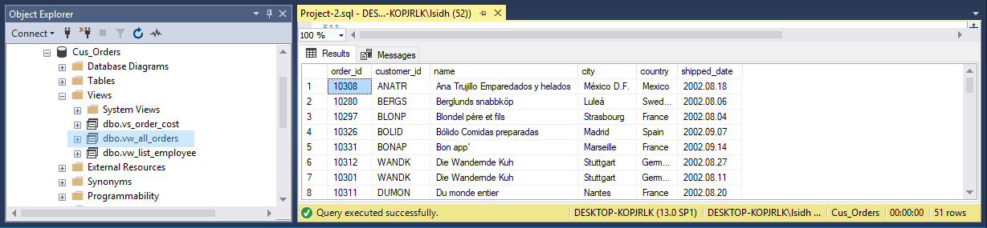

## Create a view listing the suppliers and their shipped items

Create a view listing the suppliers and the items they have shipped. Display the supplier id and name from the suppliers table, and the product id and name from the products table. Run the view. The view should produce the result set listed below, *although not necessarily in the same order.*

supplier_id supplier_name product_id product_name

--------------- ---------------------------------------- -------------- ------------------------------

9 Silver Spring Wholesale Market 23 Tunnbröd

11 Ovellette Manufacturer Company 46 Spegesild

15 Campbell Company 69 Gudbrandsdalsost

12 South Harbour Products Ltd. 77 Original Frankfurter grüne Soße

14 St. Jean's Company 31 Gorgonzola Telino

…

(77 row(s) affected)

### sql statement

CREATE VIEW vw_list_suppliers

AS

SELECT s.supplier_id,

    s.name AS supplier_name,

    p.product_id,

    p.name AS product_name

FROM suppliers s

INNER JOIN products p

    ON s.supplier_id = p.supplier_id;

GO

*-- To display the list using the above view*

SELECT *

FROM vw_list_suppliers;

GO

### result

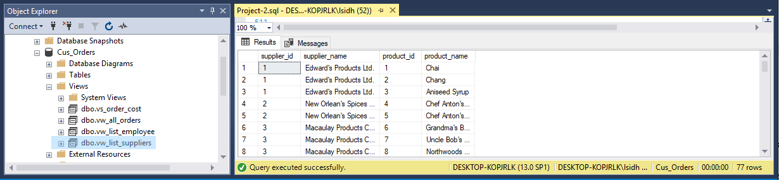

# STORED PROCEDURES AND TRIGGERS

## Create stored procedure sp_customer_city

Create a stored procedure called **sp_customer_city** displaying the customers living in a particular city. The **city** will be an **input parameter** for the stored procedure. Display the customer id, name, address, city and phone from the customers table. Run the stored procedure displaying customers living in **London**. The stored procedure should produce the result set listed below.

customer_id name address city phone

--------------- ------------------------ ---------- ------------------------------------- ------ ------------

AROUT Around the Horn 120 Hanover Sq. London (71) 555-7788

BSBEV B's Beverages Fauntleroy Circus London (71) 555-1212

CONSH Consolidated Holdings Berkeley Gardens 12 Brewery London (71) 555-2282

EASTC Eastern Connection 35 King George London (71) 555-0297

NORTS North/South South House 300 Queensbridge London (71) 555-7733

SEVES Seven Seas Imports 90 Wadhurst Rd. London (71) 555-1717

(6 row(s) affected)

### sql statements

CREATE PROCEDURE sp_customer_city (@city VARCHAR(20))

AS

SELECT customer_id,

    name,

    address,

    city,

    phone

FROM customers

WHERE city = @city;

GO

*-- To list the customers using sp_customer_city*

EXECUTE sp_customer_city 'London';

GO

### result

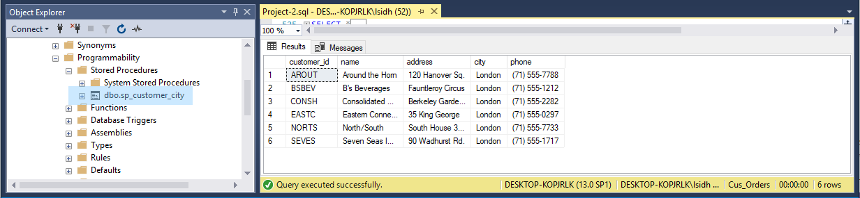

## Create stored procedure sp_orders_by_dates

Create a stored procedure called **sp_orders_by_dates** displaying the orders shipped between particular dates. The **start** and **end** date will be **input parameters** for the stored procedure. Display the order id, customer id, and shipped date from the orders table, the customer name from the customer table, and the shipper name from the shippers table. Run the stored procedure displaying orders from **January 1, 2003** to **June 30, 2003**. The stored procedure should produce the result set listed below.

order_id customer_id customer_name shipper_name shipped_date

---------- --------------- ------------------------------------- -------------------- ----------------------

10423 GOURL Gourmet Lanchonetes Federal Shipping 2003-01-18 00:00:00.000

10425 LAMAI La maison d'Asie United Package 2003-01-08 00:00:00.000

10427 PICCO Piccolo und mehr United Package 2003-01-25 00:00:00.000

...

(188 row(s) affected)

### sql statements

CREATE PROCEDURE sp_orders_by_dates (

    @start DATETIME,

    @end DATETIME

    )

AS

SELECT o.order_id,

    o.customer_id,

    c.name,

    s.name,

    o.shipped_date

FROM orders o

INNER JOIN customers c

    ON o.customer_id = c.customer_id

INNER JOIN shippers s

    ON o.shipper_id = s.shipper_id

WHERE o.shipped_date >= @start

    AND o.shipped_date <= @end;

GO

*-- display data using sp_orders_by_dates*

EXECUTE sp_orders_by_dates 'January 1, 2003',

    'June 30, 2003';

GO

### result

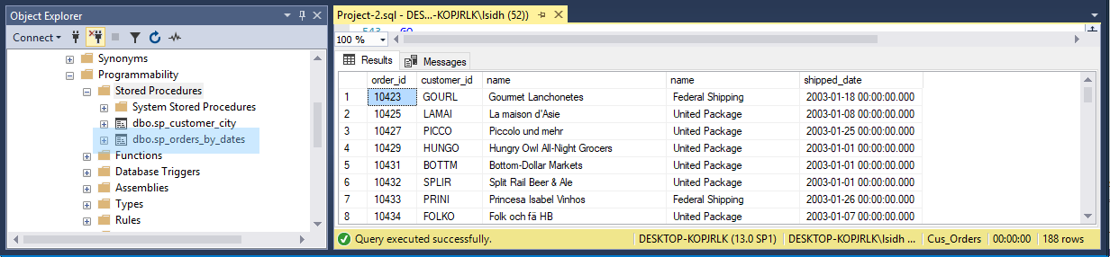

## Create stored procedure sp_product_listing

Create a stored procedure called **sp_product_listing** listing a specified product ordered during a specified month and year. The **product** and the **month** and **year** will be **input** **parameters** for the stored procedure. Display the product name, unit price, and quantity in stock from the products table, and the supplier name from the suppliers table. Run the stored procedure displaying a product name containing **Jack** and the month of the order date is **June** and the year is **2001**. The stored procedure should produce the result set listed below.

product_name unit_price quantity_in_stock supplier_name

--------------------------------------------- ------------- --------------------- -----------------------------------

Jack's New England Clam Chowder 10.1325 85 Silver Spring Wholesale Market

Jack's New England Clam Chowder 10.1325 85 Silver Spring Wholesale Market

Jack's New England Clam Chowder 10.1325 85 Silver Spring Wholesale Market

Jack's New England Clam Chowder 10.1325 85 Silver Spring Wholesale Market

(4 row(s) affected)

### sql statements

CREATE PROCEDURE sp_product_listing (

    @product VARCHAR(20),

    @month VARCHAR(3),

    @year INT

    )

AS

SELECT p.name,

    p.unit_price,

    p.quantity_in_stock,

    s.name

FROM products p

INNER JOIN suppliers s

    ON p.supplier_id = s.supplier_id

INNER JOIN order_details od

    ON od.product_id = p.product_id

INNER JOIN orders o

    ON o.order_id = od.order_id

WHERE p.name LIKE '%' + @product + '%'

    AND **CONVERT**(CHAR(3), **DATENAME**(**MONTH**, o.order_date)) = @month

    AND **CONVERT**(CHAR(4), **DATEPART**(**YEAR**, o.order_date)) = @year;

GO

*-- Display product using sp_product_listing*

EXECUTE sp_product_listing 'Jack',

    'Jun',

    '2001';

GO

### result

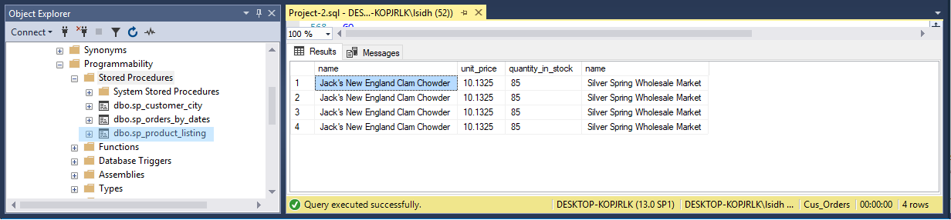

## Create a delete trigger on the order_details table

Create a **DELETE** trigger on the order_details table to display the information shown below when you issue the following statement:

DELETE order_details

WHERE order_id=10001 AND product_id=25

You should get the following results:



### SQL STATEMENTS

CREATE TRIGGER tr_UpdateQty_AftDelete ON order_details

FOR DELETE

AS

DECLARE @qtyDelete INT,

    @orderId INT,

    @productId INT;

SELECT @orderId = order_id,

    @productId = product_id,

    @qtyDelete = quantity

FROM deleted;

UPDATE products

SET quantity_in_stock = quantity_in_stock + @qtyDelete

WHERE product_id = @productId;

SELECT product_id,

    name,

    'Quantity being deleted form Order' = @qtyDelete,

    'In stock Quantity after Deletion' = quantity_in_stock

FROM products

WHERE product_id = @productId;

GO

*-- use tr_UpdateQty_AftDelete*

DELETE order_details

WHERE order_id = 10001

    AND product_id = 25;

GO

### RESULT

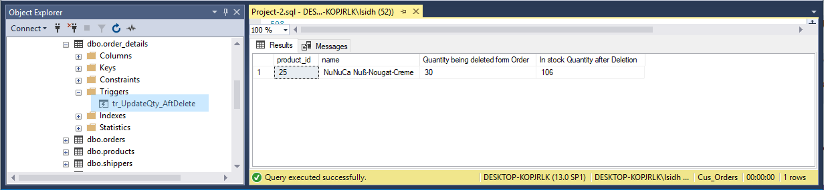

## Create an insert and update trigger tr_check_qty

Create an **INSERT** and **UPDATE** trigger called **tr_check_qty** on the order_details table to only allow orders of products that have a quantity in stock greater than or equal to the units ordered. Run the following query to verify your trigger.

UPDATE order_details

SET quantity = 30

WHERE order_id = '10044'

AND product_id = 7

### SQL STATEMENTS

CREATE TRIGGER tr_check_qty ON order_details

FOR INSERT,

    UPDATE

AS

DECLARE @newOrdQty INT, *-- new order value*

    @initOrdQty INT, *-- initial order value*

    @stockQty INT,

    @productId numid,

    @orderId numid;

*-- take the initial order value from virtual deleted table*

SELECT @initOrdQty = quantity,

    @orderId = order_id,

    @productId = product_id

FROM deleted;

*-- take the new order value from virtual inserted table*

SELECT @newOrdQty = quantity,

    @orderId = order_id,

    @productId = product_id

FROM inserted;

*-- take the product's stock qty*

SELECT @stockQty = quantity_in_stock

FROM products

WHERE product_id = @productId;

IF ((@initOrdQty - @newOrdQty) > @stockQty)

BEGIN

*-- if the stock qty is not enough for order correction*

    PRINT 'Order not allowed: Quantity in stock is not enough'

    ROLLBACK TRANSACTION

END

ELSE

BEGIN

*-- if the stock qty is enough to accomodate new order*

*-- update order_details table with the new qty value*

    UPDATE order_details

    SET quantity = @newOrdQty

    WHERE order_id = @orderId

        AND product_id = @productId;

*-- update product's stock qty with (@initOrdQty - @newOrdQty)*

    UPDATE products

    SET quantity_in_stock = quantity_in_stock + (@initOrdQty - @newOrdQty)

    WHERE product_id = @productId;

END

GO

*-- use trigger tr_check_qty*

UPDATE order_details

SET quantity = 30

WHERE order_id = '10044'

    AND product_id = 7;

GO

### RESULT

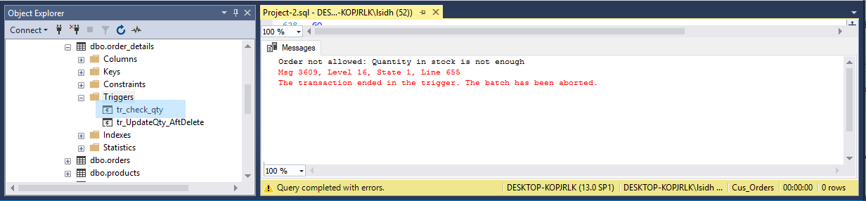

## Create a stored procedure sp_inactive_cust

Create a stored procedure called **sp_del_inactive_cust** to **delete** customers that have no orders. The stored procedure should delete **1** row.

### SQL STATEMENTS

CREATE PROCEDURE sp_del_inactive_cust

AS

DECLARE @custId char5id;

SELECT @custId = customers.customer_id

FROM customers

LEFT JOIN orders

    ON customers.customer_id = orders.customer_id

WHERE orders.customer_id IS NULL;

*-- to use trigger sp_del_inactive_cust*

DELETE

FROM customers

WHERE customer_id = @custId;

GO

### RESULT

It is only one customer that is inactive, and it has id PARIS. After the above DELETE statement is executed, the following SELECT statement shows that there is no customer_id PARIS in orders table.

SELECT *

FROM orders

WHERE customer_id = 'PARIS'

GO

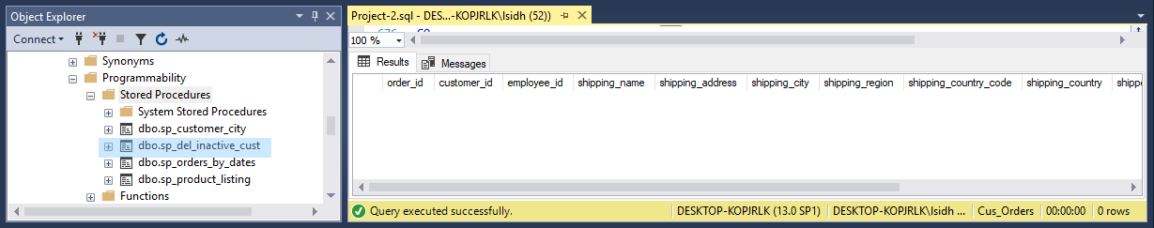

## Create a store procedure sp_employee_information

Create a stored procedure called **sp_employee_information** to display the employee information for a particular employee. The **employee id** will be an **input** **parameter** for the stored procedure. Run the stored procedure displaying information for employee id of **7**. The stored procedure should produce the result set listed below.



(1 row(s) affected)

### sql statements

CREATE PROCEDURE sp_employee_information (@empId INT)

AS

SELECT last_name,

    first_name,

    address,

    city,

    province,

    postal_code,

    'DATE OF BIRTH' = **CONVERT**(VARCHAR(12), birth_date, 109)

FROM employee

WHERE employee_id = @empId;

GO

*-- to execute sp_employee_information*

EXECUTE sp_employee_information 7

GO

### result

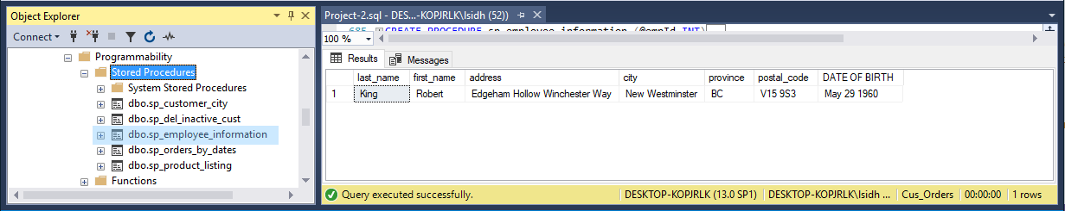

## Create a stored procedure sp_reorder_qty

Create a stored procedure called **sp_reorder_qty** to show when the reorder level subtracted from the quantity in stock is less than a specified value. The **unit** value will be an **input** **parameter** for the stored procedure. Display the product id, quantity in stock, and reorder level from the products table, and the supplier name, address, city, and province from the suppliers table. Run the stored procedure displaying the information for a value of **5**. The stored procedure should produce the result set listed below.

product_id name address city province qty reorder_level

-------------- ---------------------------------- ------------------------ ------------------ -------- --- -------------

2 Edward's Products Ltd. 1125 Howe Street Vancouver BC 17 25

3 Edward's Products Ltd. 1125 Howe Street Vancouver BC 13 25

5 New Orlean's Spices Ltd. 1040 Georgia Street West Vancouver BC 0 0

…

(23 row(s) affected)

### sql statements

CREATE PROCEDURE sp_reorder_qty (@unit INT)

AS

SELECT p.product_id,

    s.name,

    s.address,

    s.city,

    s.province,

    p.quantity_in_stock,

    p.reorder_level

FROM products p

INNER JOIN suppliers s

    ON s.supplier_id = p.supplier_id

WHERE (p.quantity_in_stock - p.reorder_level) < 5;

GO

*-- execute sp_reorder_qty*

EXECUTE sp_reorder_qty 5

GO

### result

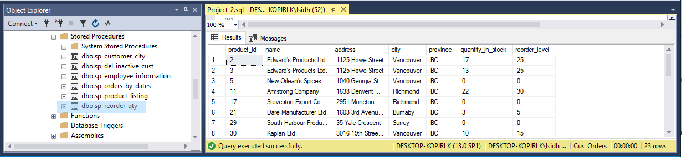

## Create a stored procedure sp_unit_prices

Create a stored procedure called **sp_unit_prices** for the product table where the **unit price** is **between particular values**. The **two unit prices** will be **input** **parameters** for the stored procedure. Display the product id, product name, alternate name, and unit price from the products table. Run the stored procedure to display products where the unit price is between **$5.00** and **$10.00**. The stored procedure should produce the result set listed below.

product_id name alternate_name unit_price

-------------- --------------------------------- -------------------------------- --------------

13 Konbu Kelp Seaweed 6.30

19 Teatime Chocolate Biscuits Teatime Chocolate Biscuits 9.66

23 Tunnbr÷d Thin Bread 9.45

45 R°gede sild Smoked Herring 9.975

47 Zaanse koeken Zaanse Cookies 9.975

52 Filo Mix Mix for Greek Filo Dough 7.35

54 TourtiÞre Pork Pie 7.8225

75 Rh÷nbrõu Klosterbier Rh÷nbrõu Beer 8.1375

1. row(s) affected)

### sql statements

CREATE PROCEDURE sp_unit_prices (

    @bottomVal MONEY,

    @topvalue MONEY

    )

AS

SELECT product_id,

    name,

    alternate_name,

    unit_price

FROM products

WHERE unit_price BETWEEN @bottomVal

        AND @topvalue;

GO

*-- execute sp_unit_prices*

EXECUTE sp_unit_prices 5.00,

    10.00

GO

### result

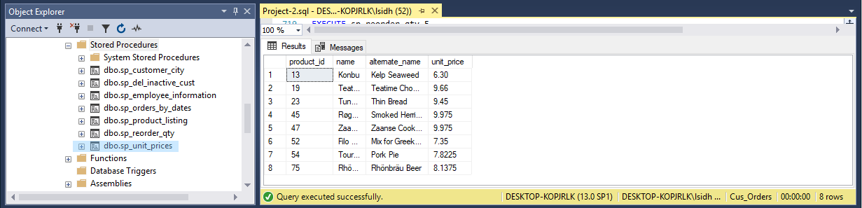

# SUMMARY

# APPENDIX A – TABLE DESIGN

**customers**

|  |  |  |  |  |
| --- | --- | --- | --- | --- |
| Column Name | Data Type | Length |  | Null Values |
| customer_id | char | 5 | User-Defined Data Type | No |
| name | varchar | 50 |  | No |
| contact_name | varchar | 30 |  |  |
| title_id | char | 3 |  | No |
| address | varchar | 50 |  |  |
| city | varchar | 20 |  |  |
| region | varchar | 15 |  |  |
| country_code | varchar | 10 |  |  |
| country | varchar | 15 |  |  |
| phone | varchar | 20 |  |  |
| fax | varchar | 20 |  |  |

**orders**

|  |  |  |  |  |
| --- | --- | --- | --- | --- |
| Column Name | Data Type | Length |  | Null Values |
| order_id | int |  | User-Defined Data Type | No |
| customer_id | char | 5 | User-Defined Data Type | No |
| employee_id | int |  |  | No |
| shipping_name | varchar | 50 |  |  |
| shipping_address | varchar | 50 |  |  |
| shipping_city | varchar | 20 |  |  |
| shipping_region | varchar | 15 |  |  |
| shipping_country_code | varchar | 10 |  |  |
| shipping_country | varchar | 15 |  |  |
| shipper_id | int |  |  | No |
| order_date | datetime |  |  |  |
| required_date | datetime |  |  |  |
| shipped_date | datetime |  |  |  |
| freight_charge | money |  |  |  |

**order_details**

|  |  |  |  |  |
| --- | --- | --- | --- | --- |
| Column Name | *Data Type* | *Length* |  | *Null Values* |
| order_id | int |  | User-Defined Data Type | No |
| product_id | int |  | User-Defined Data Type | No |
| quantity | int |  |  | No |
| discount | float |  |  | No |

**products**

|  |  |  |  |  |
| --- | --- | --- | --- | --- |
| Column Name | Data Type | Length |  | Null Values |
| product_id | int |  | User-Defined Data Type | No |
| supplier_id | int |  |  | No |
| name | varchar | 40 |  | No |
| alternate_name | varchar | 40 |  |  |
| quantity_per_unit | varchar | 25 |  |  |
| unit_price | money |  |  |  |
| quantity_in_stock | int |  |  |  |
| units_on_order | int |  |  |  |
| reorder_level | int |  |  |  |

**shippers**

|  |  |  |  |  |
| --- | --- | --- | --- | --- |
| Column Name | Data Type | Length |  | Null Values |
| shipper_id | int |  | IDENTITY | No |
| name | varchar | 20 |  | No |

**suppliers**

|  |  |  |  |  |
| --- | --- | --- | --- | --- |
| Column Name | Data Type | Length |  | Null Values |
| supplier_id | int |  | IDENTITY | No |
| name | varchar | 40 |  | No |
| address | varchar | 30 |  |  |
| city | varchar | 20 |  |  |
| province | char | 2 |  |  |

**titles**

|  |  |  |  |
| --- | --- | --- | --- |
| Column Name | *Data Type* | *Length* | *Null Values* |
| title_id | char | 3 | No |
| description | varchar | 35 | No |

Employee

|  |  |  |  |
| --- | --- | --- | --- |
| Column Name | *Data Type* | *Length* | *Null Values* |
| employee_id | int |  | No |
| last_name | varchar | 30 | No |
| first_name | varchar | 15 | No |
| address | varchar | 30 |  |
| city | varchar | 20 |  |
| province | char | 2 |  |
| postal_code | varchar | 7 |  |
| phone | varchar | 10 |  |
| birth_date | datetime |  | No |

# APPENDIX B – ERD

